|  |
| --- |
| CONTEXT FOR USER STORIES  Business Need: CBRE client Powers Development Corp. recently finished construction on a new baseball stadium. However, after operating for a few months they experienced greater than expected utilities costs causing a significant loss to investors.  Problem: CBRE commercial real estate investors face unexpected losses due an inability to anticipate utility costs accurately.  Solution: Build a machine learning algorithm that projects yearly electricity costs for a planned commercial real estate project. The algorithm will take into account multiple factors including building activity, climate, lot size, building size and zoning codes.  Below, you will find an API and UI user story that feed into a new feature we’ll call “Utility Estimator”. There would be several more stories associated with this new feature. |

**User Story Title: Breakdown by building activity**

User Story: As a commercial real estate investor, I want to be able to break down my building space by how its used i.e. building activity so that I can use this data to project my utilities costs.

Background and Business Need: Powers Development Corp. recently finished construction on a new baseball stadium. They severely underestimated the cost of electricity because they used an industry-wide per sqft cost multiple that did not capture their building activity accurately. The data collected will be used by the Utility Estimator algorithm.

Functional Requirement:

The user will break their building space down by building activity as a percent. Building activity codes will come from a system developed by the U.S. Energy Information Association.

|  |  |
| --- | --- |
| Requirement | Example |
| A user will be able to name a space within their building | E.g. Office Space, Stadium Seating, Retail  Max # of characters: 40 |
| A user will be able to assign a percent of the total building to a space | E.g 20, 35, 60  Must be an integer between 1-100 |
| A user will be able to assign a space to a specific use based on EIA-defined building activity codes | E.g Education, Lodging Nursing  *See table below for all codes and API endpoint |
| When added together all spaces must add up to 100% of the total building space | E.g A user cannot enter a space “Office” 20% and then move on. |

Source: <https://www.eia.gov/consumption/commercial/data/2012/bc/pdf/pbaplus%20examples%20and%20definitions.pdf>

Building Activity and Code

|  |  |
| --- | --- |
| Education | 14 |
| Food Sales | 06 |
| Food service | 15 |
| Health-Care Inpatient | 16 |
| Health-Care Outpatient | 08 |
| Lodging | 18 |
| Nursing | 17 |
| Mercantile | 25 |
| Strip shopping mall | 23 |
| Enclosed mall | 24 |
| Office | 02 |
| Public assembly | 13 |
| Public order and safety | 07 |
| Religious worship | 12 |
| Service | 26 |
| Nonrefrigerated Warehouse | 05 |
| Refrigerated Warehouse | 11 |
| Other | 91 |
| Laboratory | 04 |
| Vacant | 01 |

Implementation Note:

Building activity codes can be retrieved from the endpoint GET <https://api.cbre.com/api/V1/utility-estimator/building-activity-codes>

See documentation here - <link to documentation>

See next page for UI design

Wireframe:

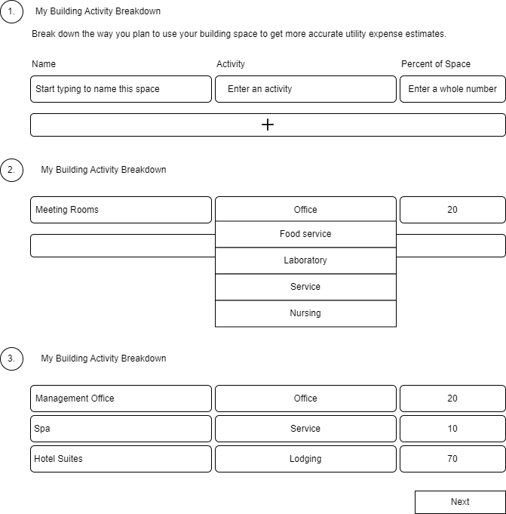

Acceptance Criteria:

A real estate developer can add the following breakdown to the UI:

* Office: 20
* Laboratory: 30
* Food Sales: 50

A user cannot proceed to the next step after entering the following breakdown since decimals are not allowed:

* Office: 21.5
* Laboratory: 28.5
* Food Sales: 50

A user cannot proceed to the next step after entering the following breakdown since the percentages do not add up to 100:

* Office: 20
* Laboratory: 30

**User Story Title: Get building activity codes endpoint**

User Story: As a user, I want to be able to get a list of all Energy Information Agency building activity codes.

Background and Business Need: Building activity codes describe how a space is used and are valuable for analyzing a property’s worth, its utility costs, and potential investment return. These building activity codes will be used in a feature called Utility Estimator that will help real estate developers estimate their utility costs prior to construction.

Functional Requirement

|  |  |
| --- | --- |
| Requirement | Example |
| Return list of Energy Information Administration building activity codes complete with activity name and code  Source: <https://www.eia.gov/consumption/commercial/data/2012/bc/pdf/pbaplus%20examples%20and%20definitions.pdf>  **\*\*Note:** ONLY use activity codes from the second column “Principal building activity variable available in public use data (PBA)” | E.g.  Activity name: Office  Code: 02  See table below for the complete list. |

Building Activity and Code

|  |  |
| --- | --- |
| Education | 14 |
| Food Sales | 06 |
| Food service | 15 |
| Health-Care Inpatient | 16 |
| Health-Care Outpatient | 08 |
| Lodging | 18 |
| Nursing | 17 |
| Mercantile | 25 |
| Strip shopping mall | 23 |
| Enclosed mall | 24 |
| Office | 02 |
| Public assembly | 13 |
| Public order and safety | 07 |
| Religious worship | 12 |
| Service | 26 |
| Nonrefrigerated Warehouse | 05 |
| Refrigerated Warehouse | 11 |
| Other | 91 |
| Laboratory | 04 |
| Vacant | 01 |

Request:

GET <https://api.cbre.com/api/V1/utility-estimator/>building-activity-codes

Response:

|  |  |  |
| --- | --- | --- |
| HTTP Status Code | Description | Response |
| 200 Ok | Successful | {  “building_codes”: [  {  “activity”: “Education”,  “code”: 14  },  {  “activity”: Food service”,  “code”: 15  }  …  ]} |

Acceptance Criteria:

When a call is made to GET <https://api.cbre.com/api/V1/utility-estimator/building-activity-codes>, 20 activity codes are returned each having a code.